Virtue one - atma-anatma
Here is the complete, production-ready curriculum for the first virtue, Atma-Anatama Viveka (Discrimination), incorporating all requested format changes, characters, and source citations.

🌿 VIRTUE OVERVIEW: Atma-Anatama Viveka
- Theme Mantra: "I am the driver, not the car!"
- CASEL Competency: Self-Awareness
- Executive Function: Inhibitory Control
- Color Theme: PALETTE-01 (Mint Green & Warm Gold)

POST 01 — 📖 STORY CAROUSEL: Source 1 (Bhagavad Gita)
- Production Metadata: Story ID: PK-V1-S1 | Source: Gita 2.10 | Characters: CHAR-001 Arin, CHAR-008 Ved | Env: TER-006 River Bank | Symbol: SYM-GIT-003 Chariot.
- Cover Page: Arin and the Wobbly Stream. A story about noticing your feelings before they take over.
- Page 1: Arin Rabbit loved exploring the meadow. One morning, he reached a tiny stream and suddenly his feet felt wobbly. He didn't know why.
- Visual: CHAR-001 Arin | Expression: Neutral | Pose: Standing.
- Page 2: Arin looked around. "Maybe I'm not brave enough to cross," he whispered. His tummy felt funny and his heart beat faster.
- Visual: CHAR-001 Arin | Expression: Worried | Pose: Thinking.
- Page 3: Ved Owl landed beside him. "What are you feeling right now?" he asked gently. Arin paused and replied, "I think... I'm feeling nervous."
- Visual: CHAR-008 Ved | Expression: Calm | Pose: Pointing.
- Page 4: Ved smiled. "That's a wonderful thing to notice. Everyone feels nervous sometimes. When we know what we're feeling, we can choose what to do next."
- Visual: CHAR-008 Ved | Expression: Happy | Pose: Sitting.
- Page 5: Arin took one slow breath, then another. His feet still felt a little wobbly, but now he understood why. Carefully, he hopped across the stream.
- Visual: CHAR-001 Arin | Expression: Determined | Pose: Jumping.
- Page 6: Reflection: Have you ever felt like your thoughts were racing? | Wisdom Symbol: SYM-GIT-003 Chariot | Mantra: "I am the driver, not the car."

POST 02 — 📜 WISDOM CONNECTION: Source 1 (Bhagavad Gita)
- Page 1 (Source Card):
- Tradition: Bhagavad Gita
- Teaching: Finding Your Calm Center
- Mapped Symbol: SYM-GIT-003 Chariot
- Book: Bhagavad-gītā As It Is | Author: A.C. Bhaktivedanta Swami Prabhupāda
- 📜 Full Verse: $$tamuvāca\ hṛṣīkeśaḥ\ prahasanniva\ bhārata$$ $$sēnayōrubhayōrmadhyē\ viṣīdantamidaṃ\ vacaḥ$$ (2.10)
- Page 2: Sanskrit Word: स्थितप्रज्ञ (Sthitaprajña) | Meaning: A calm and steady mind | Pronunciation: Sthee-tha-prah-jnyah.
- Page 3: Application: Big feelings like worry are normal. You are the "Quiet Captain" who notices them and then chooses how to act. | Tiny Practice: Sit tall, take three slow breaths, and watch one feeling come and go.
- Page 4: Affirmation: 💛 I choose my actions with a calm mind. | Did You Know? Krishna’s smile shows that a kind face can change the rhythm of any difficult moment.

POST 03 — 📖 STORY CAROUSEL: Source 2 (Ganesha Stories)
- Production Metadata: Story ID: PK-V1-S2 | Source: Ganesha 31 | Characters: CHAR-005 Kavi, CHAR-002 Bodhi | Env: TER-008 Clearing | Prop: FOD-005 Modak | Symbol: SYM-GAN-002 Mouse.
- Cover Page: Kavi and the Jumpy Mouse. A story about being the boss of your busy desires.
- Page 1: Kavi Monkey saw a giant Modak. "I want it now!" he shouted. He felt like a tiny mouse was pulling his arms toward the treat.
- Visual: CHAR-005 Kavi | Expression: Excited | Pose: Jumping.
- Page 2: Kavi was about to grab it when Bodhi Elephant walked over. "Kavi, use your Wisdom Pilot. Ride your desires like a mouse."
- Visual: CHAR-002 Bodhi | Expression: Calm | Pose: Standing.
- Page 3: Kavi stopped and imagined he was sitting right on top of that restless mouse. He realized he could wait.
- Visual: CHAR-005 Kavi | Expression: Thinking | Pose: Sitting.
- Page 4: "I'm the boss today," Kavi told the mouse. He waited for his friends to arrive before taking the first bite.
- Visual: CHAR-005 Kavi | Expression: Proud | Pose: Celebrating.
- Page 5: Sharing the treat made Kavi feel even better than eating it alone. He steered his feelings to the Kind Path.
- Visual: CHAR-005 Kavi | Expression: Happy | Pose: Standing.
- Page 6: Reflection: Is there something you want so badly it makes you jumpy? | Wisdom Symbol: SYM-GAN-002 Mouse | Mantra: "I am a Wisdom Pilot!"

POST 04 — 📜 WISDOM CONNECTION: Source 2 (Ganesha Stories)
- Page 1 (Source Card):
- Tradition: Ganesha Stories
- Teaching: The Mouse and the Master
- Mapped Symbol: SYM-GAN-002 Mouse
- Book: Ganapati Atharvashirsha | Author: Attributed to Sage Atharvan
- 📜 Full Verse: Mushakavahana (Verse 9)
- Page 2: Sanskrit Word: इन्द्रिय निग्रह (Indriya Nigraha) | Meaning: Mastery over the senses | Pronunciation: In-dree-yah Ni-gruh-hah.
- Page 3: Application: Your mind is like a busy mouse. When you use your "Wisdom Pilot," you teach that mouse to carry you toward your goals. | Tiny Practice: When you want something "right now," count to five before moving.
- Page 4: Affirmation: 🐭 I am the master of my jumpy thoughts. | Did You Know? Ganesha sits on his mouse to show that wisdom is stronger than being bossy or greedy.

POST 05 — 📖 STORY CAROUSEL: Source 3 (Hanuman Series)
- Production Metadata: Story ID: PK-V1-S3 | Source: Hanuman 31 | Characters: CHAR-010 Anu, CHAR-008 Ved | Env: TER-002 Forest Floor | Symbol: SYM-HAN-009 Leap.
- Cover Page: Anu’s Quiet Observer. A story about watching your thoughts fly by.
- Page 1: Anu Mouse was ready to learn a giant leap, but her mind was full of "what-ifs." Her mind-mirror felt very dusty!
- Visual: CHAR-010 Anu | Expression: Worried | Pose: Thinking.
- Page 2: Ved Owl landed softly. "Anu, you are not the noise," he hooted. "Be the Silent Watcher in the sky."
- Visual: CHAR-008 Ved | Expression: Calm | Pose: Pointing.
- Page 3: Anu took a breath and imagined she was a quiet cloud watching her own "Monkey Mind" chatter.
- Visual: CHAR-010 Anu | Expression: Calm | Pose: Sitting.
- Page 4: She saw the worry, but she didn't listen to it. Suddenly, the "dust" of distraction vanished.
- Visual: CHAR-010 Anu | Expression: Curious | Pose: Standing.
- Page 5: Anu leaped! She flew through the air, watching her thoughts go by while she stayed steady and focused.
- Visual: CHAR-010 Anu | Expression: Determined | Pose: Jumping.
- Page 6: Reflection: Can you watch a "grumpy thought" fly away like a bird? | Wisdom Symbol: SYM-HAN-009 Leap Across Ocean | Mantra: "I watch my thoughts, I choose my way."

POST 06 — 📜 WISDOM CONNECTION: Source 3 (Hanuman Series)
- Page 1 (Source Card):
- Tradition: Hanuman Series
- Teaching: The Mind-Mirror
- Mapped Symbol: SYM-HAN-008 Lotus
- Book: Hanuman Chalisa | Author: Tulsidas
- 📜 Full Verse: $$Shri\ guru\ charana\ saroja\ raja,\ Nija\ mana\ mukuru\ sudhaari$$ (Doha 1)
- Page 2: Sanskrit Word: साक्षी (Sakshi) | Meaning: The silent observer/witness | Pronunciation: Sahk-shee.
- Page 3: Application: Your mind can be noisy, but you are the "Watcher." You can look at your thoughts without having to do everything they say. | Tiny Practice: Imagine your thoughts are clouds floating in the sky. Just watch them float by without touching them.
- Page 4: Affirmation: 👀 I am the quiet watcher of my busy mind. | Did You Know? Hanuman polished his mind with gratitude first so he could see his "Super Self" clearly.

POST 07 — 📖 STORY CAROUSEL: Source 4 (Ancient Wisdom)
- Production Metadata: Story ID: PK-V1-S4 | Source: Ancient 29 | Characters: CHAR-004 Chinu, CHAR-003 Tara | Env: TRE-002 Banyan Tree | Symbol: SYM-ANC-012 Mirror.
- Cover Page: Chinu and the Two Birds. A story about the part of you that stays happy.
- Page 1: Chinu Squirrel was trying to collect berries, but she felt grumpy because she wanted more.
- Visual: CHAR-004 Chinu | Expression: Sad | Pose: Thinking.
- Page 2: Tara Turtle pointed up. "Look, Chinu. One bird eats the fruit, but the other bird just watches and smiles."
- Visual: CHAR-003 Tara | Expression: Calm | Pose: Pointing.
- Page 3: Chinu stopped. She realized she could be the bird that just watches. She didn't have to be grumpy about the berries.
- Visual: CHAR-004 Chinu | Expression: Curious | Pose: Sitting.
- Page 4: Chinu felt her "Inner Sparkle" return. She smiled just like the watcher bird, feeling peaceful inside.
- Visual: CHAR-004 Chinu | Expression: Happy | Pose: Standing.
- Page 5: Now, even the berries tasted better because Chinu was eating with a calm heart!
- Visual: CHAR-004 Chinu | Expression: Proud | Pose: Celebrating.
- Page 6: Reflection: Can you find the "smiling watcher" inside you today? | Wisdom Symbol: SYM-ANC-012 Mirror | Mantra: "I am the bird that watches."

POST 08 — 📜 WISDOM CONNECTION: Source 4 (Ancient Wisdom)
- Page 1 (Source Card):
- Tradition: Ancient Wisdom (Upanishads)
- Teaching: The Witness Bird
- Mapped Symbol: SYM-ANC-012 Mirror
- Book: The Principal Upanishads | Author: S. Radhakrishnan
- 📜 Full Verse: $$dvā\ suparṇā\ sayujā\ sakhāyā\ samānaṃ\ vṛkṣaṃ\ pariṣasvajāte\ |$$ $$tayoranyaḥ\ pippalaṃ\ svādvattyanaśnannanyo\ abhicākaśīti\ ||$$ (3.1.1)
- Page 2: Sanskrit Word: विवेक (Viveka) | Meaning: Discrimination between self and non-self | Pronunciation: Vee-vay-kah.
- Page 3: Application: You have two parts: one that experiences things (like eating) and one that just watches (your quiet self). Being the watcher keeps you calm. | Tiny Practice: Look in a mirror. The "you" looking is the Watcher. Say: "I see you, and I am steady."
- Page 4: Affirmation: 🌟 My inner self is always peaceful and clear. | Did You Know? This story is thousands of years old and helps us find our "Quiet Center."

POST 09 — 📖 STORY CAROUSEL: Source 5 (World Wisdom)
- Production Metadata: Story ID: PK-V1-S5 | Source: World 3 | Characters: CHAR-012 Vani, CHAR-002 Bodhi | Env: TER-004 Hill | Symbol: SYM-WLD-004 Stone.
- Cover Page: Vani and the Heavy Root. A story about staying steady when life gets fast.
- Page 1: Vani Parrot was trying to tell a story, but the playground was so noisy! Everyone was running and shouting.
- Visual: CHAR-012 Vani | Expression: Worried | Pose: Standing.
- Page 2: Vani felt herself getting "light" and wobbly. She started shouting too, and her heart felt like a leaf in the wind.
- Visual: CHAR-012 Vani | Expression: Excited | Pose: Jumping.
- Page 3: Bodhi Elephant sat still on the hill. "Vani, find your heavy root. The still is the master of unrest."
- Visual: CHAR-002 Bodhi | Expression: Calm | Pose: Sitting.
- Page 4: Vani landed and imagined she had roots growing deep into the hill. She let the noise blow past her.
- Visual: CHAR-012 Vani | Expression: Calm | Pose: Sitting.
- Page 5: Vani felt strong and steady. She wasn't blowing away anymore. She was the boss of her own peace!
- Visual: CHAR-012 Vani | Expression: Proud | Pose: Standing.
- Page 6: Reflection: What is your "Heavy Root" (like being kind) that keeps you steady? | Wisdom Symbol: SYM-WLD-004 Stone | Mantra: "I am rooted and steady."

POST 10 — 📜 WISDOM CONNECTION: Source 5 (World Wisdom)
- Page 1 (Source Card):
- Tradition: World Wisdom (Taoism)
- Teaching: Self-Regulation (The Heavy Root)
- Mapped Symbol: SYM-WLD-004 Stone
- Book: Tao Te Ching | Author: Lao Tsu (Translators: Gia-Fu Feng & Jane English)
- 📜 Full Verse: "The heavy is the root of the light; The still is the master of unrest." (Chapter 26)
- Page 2: Root Word: समत्व (Samatva) | Meaning: Balance/Possession of oneself | Pronunciation: Suh-maht-vum.
- Page 3: Application: When things get too busy, don't let your feelings blow you away. Stay connected to your values—they are your "Heavy Root." | Tiny Practice: Stand with feet wide. Imagine anchors on your feet. Breathe out and say: "I am steady."
- Page 4: Affirmation: 🌳 I stay grounded in what is good. | Did You Know? Taoist wisdom teaches that the root that stays still is the strongest part of the tree!

POST 11 — 🌍 VIRTUE WRAP-UP
- Saturday: Symbol Spotlight: The Chariot SYM-GIT-003. Your body is a car, and you are the "Quiet Captain." Hold the reins of your breath gently, smile, and choose your way.
- Sunday: Weekly Wisdom Map:
- Gita: Be the driver.
- Ganesha: Ride your mouse.
- Hanuman: Watch your mind.
- Ancient: Be the watcher bird.
- World: Stay rooted.
- Weekly Hero Practice: The Driver's Seat. Sit tall. Place hands on knees. Imagine your thoughts are horses running past. Say: "I am the driver, not the car."
Shall we proceed to the carousels for the next virtue: Nityatvam (Eternality)?
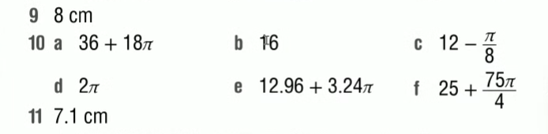

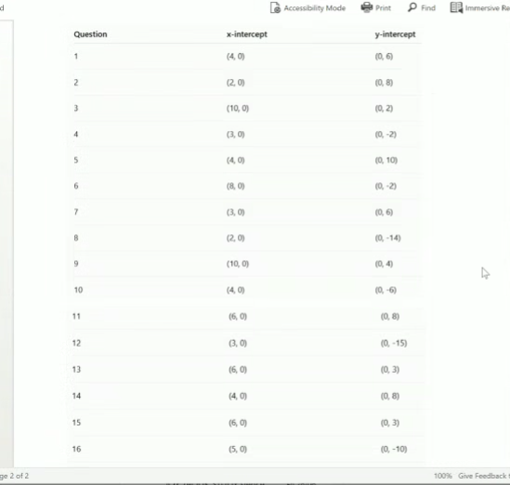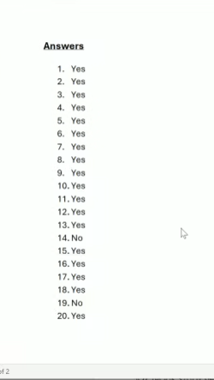
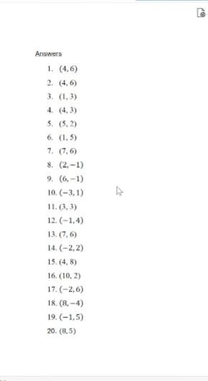

Tab 2

